Unit 1 Student Notes
  - Course: Data Communication and Networks (BCSIT / BScIT level)
  - Prepared from the syllabus and the uploaded textbook support

What this handout gives you
A clean, student-ready note for Unit 1 arranged exactly in syllabus order: 1.1 to 1.13.
Simple definitions, short examples, exam tips, formula boxes, and neatly aligned diagrams.
Extra emphasis on the topics that are usually asked in short answers, definitions, and numericals.

Unit 1: Introduction to Data Communication
Unit 1 introduces the foundation of how information is sent from one point to another in a communication system. It explains what data communication means, how devices exchange data, what makes communication effective, and how analog information is turned into digital form for computer networks. The unit also covers important theorems such as Nyquist Sampling Theorem and Shannon Channel Capacity Theorem, along with bit rate, baud rate, and line coding. This unit is important because every computer network finally depends on correct, efficient, and reliable transfer of bits over some medium.

Learning objectives (from syllabus)
- Understand the concept of data and its significance in communication systems.
- Explore different data transmission modes such as simplex, half-duplex, and full-duplex.
- Identify the fundamental characteristics of data communication systems.
- Illustrate the block diagram of a digital communication system.
- Compare and contrast the advantages of digital transmission over analog transmission.
- Explain the statement of the Nyquist Sampling Theorem.
- Apply Shannon’s Channel Capacity Theorem to determine the maximum rate of error-free data transmission over a communication channel.
- Solve numerical problems to calculate channel capacity based on given parameters.
- Explain the concept of line coding and its role in digital data transmission.
- Discuss the characteristics and implementation of unipolar, polar, and bi-polar line coding schemes.

Sub-units covered in this note
- 1.1 Introduction to data communication
- 1.2 Data transmission modes (simplex, half-duplex, and full-duplex)
- 1.3 Fundamental characteristics of data communication
- 1.4 Components of data communication system
- 1.5 Block diagram of digital communication system
- 1.6 Introduction to analog to digital system
- 1.7 Advantages of digital transmission over analog
- 1.8 Sampling theorem / Nyquist Sampling Theorem
- 1.9 Numerical
- 1.10 Shannon Channel Capacity Theorem
- 1.11 Bit rate vs baud rate
- 1.12 Numerical
- 1.13 Line coding (Unipolar, Polar and Bi-Polar)

1.1 Introduction to Data Communication
Data communication is the exchange of data between two or more devices through a transmission medium. The data may be text, numbers, image, audio, video, or computer files. In simple words, whenever one device sends information and another device receives it, data communication is taking place.
In networking, data communication is not limited to two nearby computers. It can happen within a room, across a building, between cities, or through the Internet. The communication may use copper wire, optical fiber, radio waves, or satellite links.
- A sender must have some data to send.
- A receiver must be able to accept and understand the data.
- A communication path must exist between them.
- Both sides must follow some agreed rules, called protocols.
Simple example
When a student opens a website on a laptop, the laptop sends a request to the web server.
The request travels through a network medium.
The server replies with the web page data.
This whole exchange is data communication.

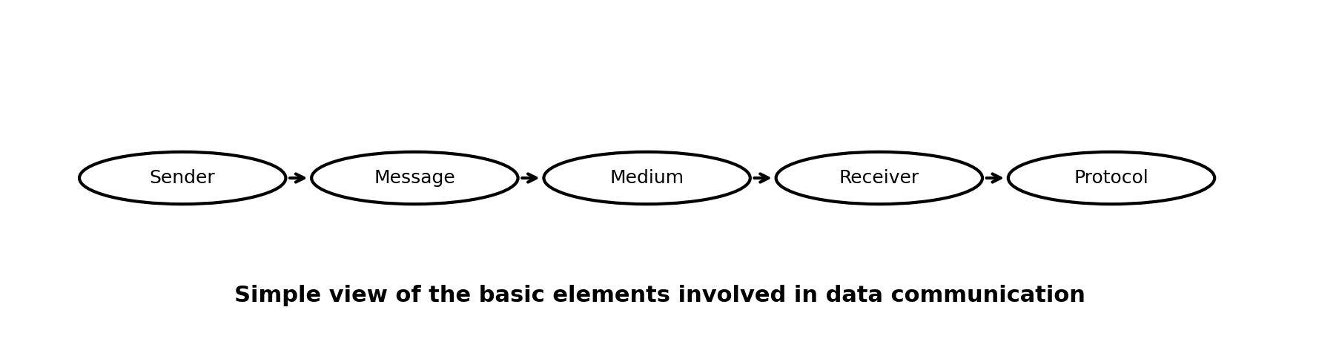
Figure 1. Basic elements involved in data communication
Key terms to remember
Data: raw facts or information that can be processed.
Communication: transfer of information from one point to another.
Medium: physical path such as wire, fiber, or wireless channel.
Protocol: rules that control communication.

1.2 Data Transmission Modes
Data transmission mode tells us how data flows between two connected devices. This topic is simple but very important because exam questions often ask for definitions and examples.
Mode | Meaning and example
Simplex | Communication takes place in one direction only. Example: keyboard to computer, TV broadcasting.
Half-duplex | Communication takes place in both directions, but not at the same time. Example: walkie-talkie.
Full-duplex | Communication takes place in both directions at the same time. Example: telephone call, video call.

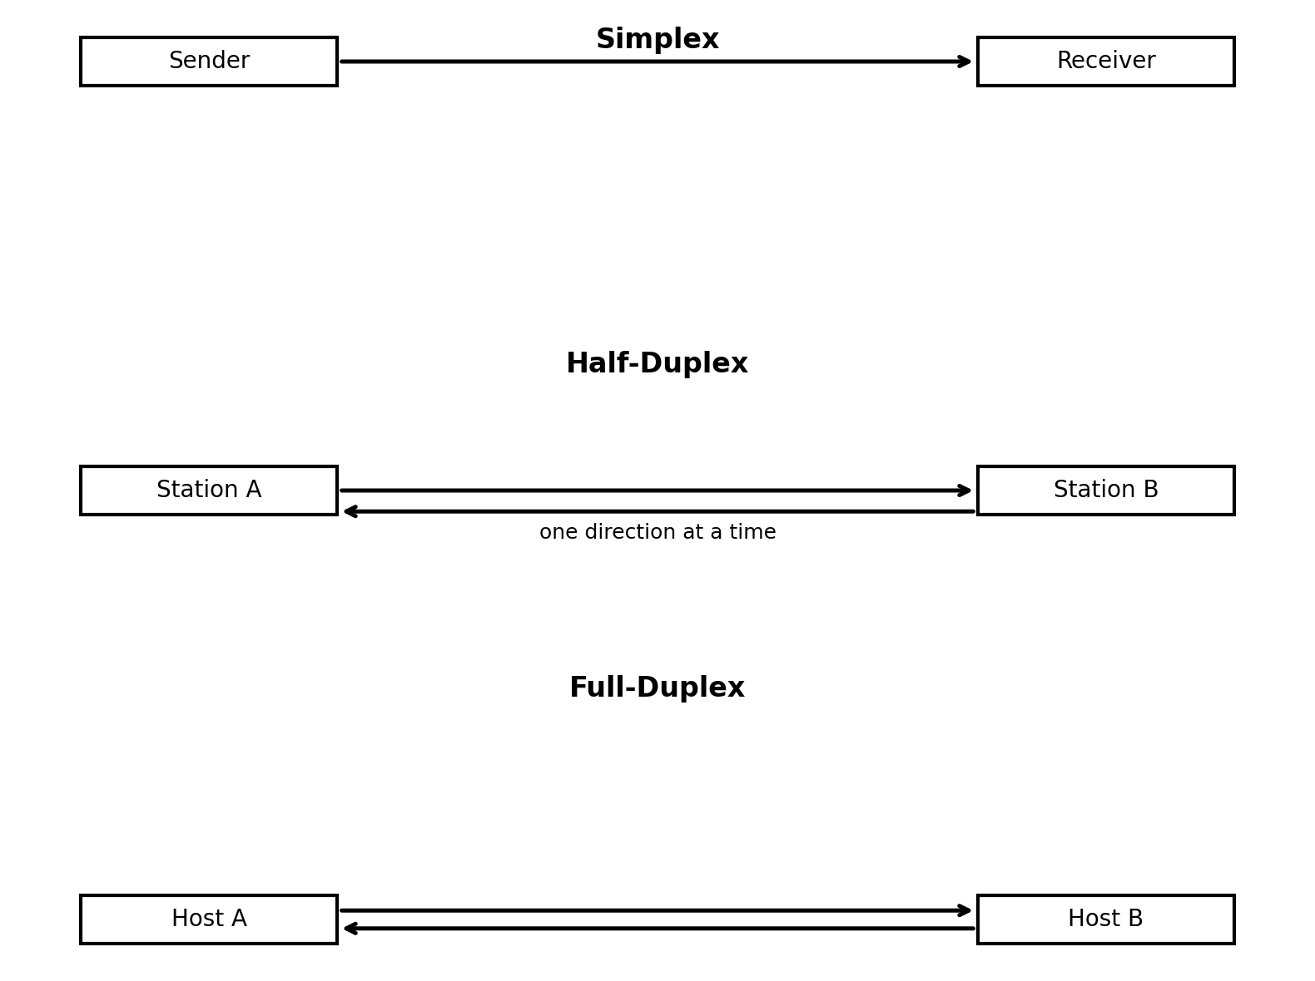
Figure 2. Simplex, half-duplex, and full-duplex communication
A good way to remember the difference is to think about everyday communication. If only one side talks, it is simplex. If both sides can talk but must wait for their turn, it is half-duplex. If both can talk together, it is full-duplex.
Quick comparison
Simplex is cheapest and simplest, but there is no reply path.
Half-duplex allows two-way communication, but only one side transmits at a time.
Full-duplex gives the best communication experience because sending and receiving happen simultaneously.

Mnemonic
S-H-F = Single direction, Hold your turn, Free both ways

1.3 Fundamental Characteristics of Data Communication
An effective data communication system is not judged only by whether data moves. It is judged by whether data reaches the right place, reaches correctly, and reaches on time.
Characteristic | Explanation
Delivery | Data must reach the correct destination device or user.
Accuracy | Data must be delivered without errors, loss, or modification.
Timeliness | Data must reach the destination in the required time; delay should be acceptable.
Jitter | The variation in packet arrival time should be low, especially for audio and video applications.

For example, if a live online class reaches the student 30 seconds late, it has a timeliness problem. If the voice breaks and arrives at uneven intervals, it has a jitter problem. If the wrong file is received or bits change during transmission, it is an accuracy problem.
Exam answer pattern
When asked to write the characteristics of effective data communication, mention:
1. Delivery 2. Accuracy 3. Timeliness 4. Jitter

1.4 Components of Data Communication System
Every communication system has a few essential parts. If one part is missing, successful communication becomes difficult or impossible.
Component | Role in communication
Sender | The device that sends the data, such as a computer, phone, or sensor.
Message | The information being sent, such as text, image, audio, or video.
Transmission medium | The path over which the message travels; for example copper cable, optical fiber, or air in wireless communication.
Receiver | The device that receives the message.
Protocol | The set of rules that governs the format, order, and meaning of transmitted data.

These components work together. The sender creates a message, the message travels through a medium, the receiver accepts it, and the protocol makes sure both sides follow the same rules.
Real-life example: sending an e-mail
Sender: your laptop or phone
Message: the e-mail text and attachment
Medium: Wi-Fi, router, ISP link, and Internet path
Receiver: the recipient's mail server and then recipient's device
Protocol: SMTP for sending mail, plus other protocols for access

1.5 Block Diagram of Digital Communication System
A digital communication system is usually represented by a block diagram. The purpose of the diagram is to show the path followed by the information from source to destination.
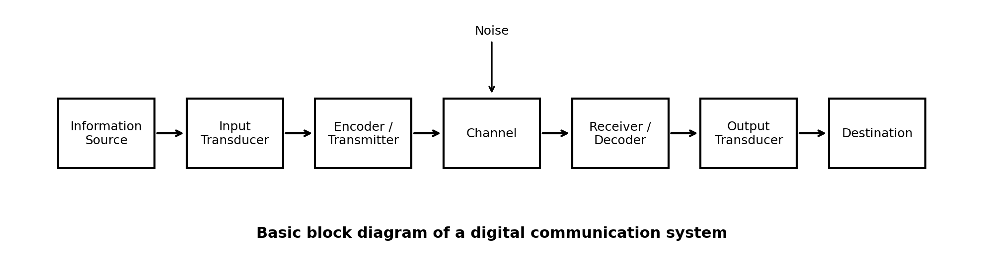
Figure 3. Basic block diagram of a digital communication system
Block | Function
Information source | Produces the original message.
Input transducer | Converts the physical message into electrical form. Example: microphone converts sound into electrical signal.
Encoder / transmitter | Prepares the signal for transmission by coding or modulation.
Channel | Carries the signal from transmitter to receiver.
Noise | Undesired disturbance that may affect the signal while travelling in the channel.
Receiver / decoder | Recovers the data from the received signal.
Output transducer | Converts the electrical form back into a usable physical form. Example: speaker converts electrical signal into sound.
Destination | The final user or device for which the information is intended.

You should be able to draw this block diagram neatly in exams. Keep the blocks in a left-to-right sequence and show noise entering the channel from above or below.
Short explanation for exam
The information source generates the message.
The transmitter encodes it and sends it through the channel.
Noise may affect the signal during transmission.
The receiver decodes the signal and delivers the message to the destination.

1.6 Introduction to Analog to Digital System
Many real-world signals are analog. Voice, temperature, light intensity, and human speech vary continuously with time. Computers, however, work mainly with digital data, which uses discrete values such as 0 and 1. Therefore, an analog-to-digital system is required to convert analog information into digital form.
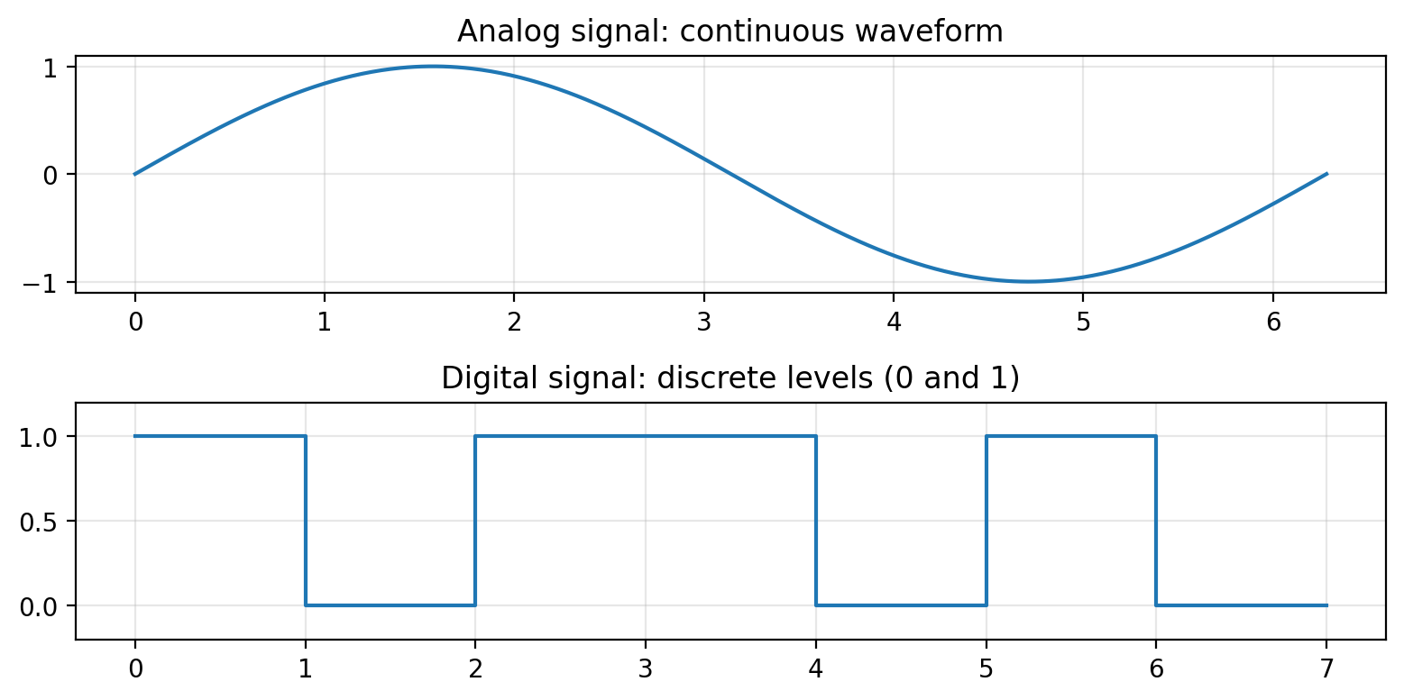
Figure 4. Analog signal versus digital signal
- Analog signal: continuous in time and amplitude.
- Digital signal: discrete in time and represented with fixed levels or binary digits.
- Conversion is needed so that computers can process, store, and transmit information efficiently.
The analog-to-digital conversion process usually involves three main steps:
- Sampling: taking the value of an analog signal at regular time intervals.
- Quantization: rounding each sampled value to one of a limited number of levels.
- Encoding: representing the quantized values in binary form.
Simple example
When you speak into a smartphone microphone, your voice is originally an analog signal.
The phone samples the sound wave many times per second.
The sampled values are quantized and encoded into bits.
Those bits are then stored, processed, or sent over a network.

1.7 Advantages of Digital Transmission over Analog
Modern computer networks prefer digital transmission because digital signals are easier to process, store, regenerate, and protect. Although analog systems were common in earlier communication systems, digital communication offers many practical benefits.
- Better noise immunity: digital signals can often be regenerated even after some noise is added.
- Easy storage and processing: digital data can be handled directly by computers and software systems.
- Improved security: encryption techniques are easier to apply to digital data.
- Error detection and correction: digital systems can use parity, checksum, or coding methods.
- Efficient multiplexing and compression: digital information is easier to combine and compress.
- High compatibility with modern networks: the Internet and computer systems are naturally digital.
Type | General nature
Analog transmission | More affected by noise; difficult to regenerate exactly; less convenient for storage and processing.
Digital transmission | More reliable; easy to regenerate, store, process, secure, and integrate with computer networks.

Mnemonic
N-S-E-C-I = Noise resistance, Storage, Encryption, Correction, Integration

1.8 Sampling Theorem / Nyquist Sampling Theorem
The Nyquist Sampling Theorem tells us the minimum sampling rate needed to reconstruct an analog signal correctly after converting it into digital form.
Statement: A band-limited analog signal can be reconstructed perfectly if the sampling frequency is at least twice the highest frequency component present in the signal.
Formula box
Sampling frequency fs ≥ 2fmax
Here, fs = sampling frequency
fmax = highest frequency present in the analog signal
The minimum value 2fmax is called the Nyquist rate.

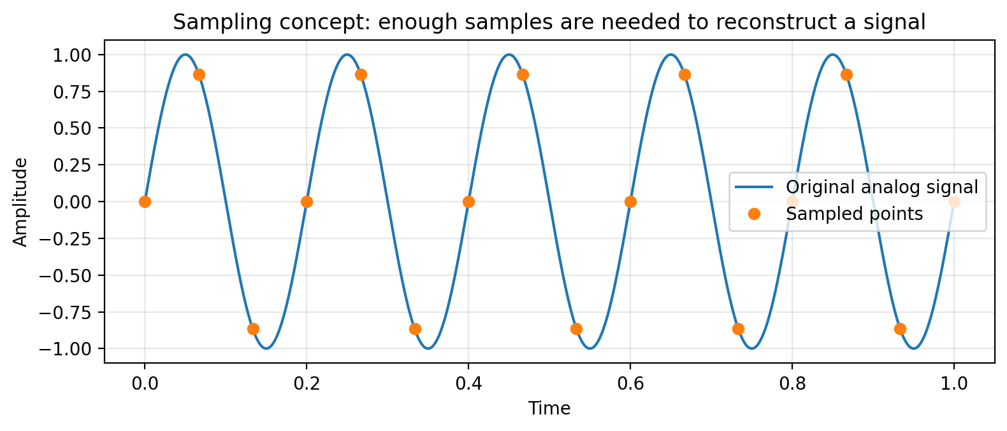
Figure 5. Sampling idea used in the Nyquist theorem
If we sample below the Nyquist rate, the reconstructed signal becomes inaccurate. This wrong representation is called aliasing. In exam answers, you should mention that the theorem helps decide the minimum safe sampling frequency.
Solved example 1
If the highest frequency component of a signal is 4 kHz, then the minimum sampling frequency is:
fs = 2 × 4 kHz = 8 kHz
So the signal must be sampled at 8 kHz or higher.

Solved example 2
If a signal is sampled at 12 kHz, what maximum signal frequency can be reconstructed?
By Nyquist, fs = 2fmax
Therefore fmax = fs / 2 = 12 kHz / 2 = 6 kHz

1.9 Numerical
This sub-unit is meant for practicing calculations related to sampling and basic communication formulas. Write every step clearly in numericals: first write the given values, then the formula, then substitution, and finally the answer with units.
Numerical 1: Minimum sampling frequency
Given: highest frequency fmax = 5 kHz
Formula: fs = 2fmax
Calculation: fs = 2 × 5 kHz = 10 kHz
Answer: minimum sampling frequency = 10 kHz

Numerical 2: Find maximum signal frequency
Given: sampling frequency fs = 44 kHz
Formula: fmax = fs / 2
Calculation: fmax = 44 / 2 = 22 kHz
Answer: highest signal frequency = 22 kHz

Common mistakes in numericals
Do not forget the unit (Hz, kHz, Mbps, bps).
Read whether the question asks for minimum sampling frequency or maximum signal frequency.
If values are in kHz, keep the answer in kHz unless conversion is requested.
Always write the final answer in a complete sentence.

1.10 Shannon Channel Capacity Theorem
Nyquist deals with sampling of analog signals. Shannon, on the other hand, deals with the maximum data rate of a noisy communication channel. This theorem tells us the highest theoretical error-free transmission rate possible for a channel of a given bandwidth and signal-to-noise ratio.
Formula box
C = B log2(1 + S/N)
C = channel capacity in bits per second (bps)
B = bandwidth of the channel in hertz (Hz)
S/N = signal-to-noise ratio in linear form

The theorem shows two important ideas:
- If bandwidth increases, channel capacity increases.
- If signal-to-noise ratio increases, channel capacity also increases.
- No matter how advanced the coding is, the channel cannot exceed this theoretical limit.
Sometimes SNR is given in decibels (dB). Then we use the relation:
Useful relation
SNR(dB) = 10 log10(S/N)
So, if needed: S/N = 10^(SNR(dB)/10)

Solved example
Given bandwidth B = 3000 Hz and S/N = 1000
Formula: C = B log2(1 + S/N)
So, C = 3000 × log2(1001)
Since log2(1001) ≈ 9.97, C ≈ 3000 × 9.97 = 29,910 bps
Answer: channel capacity ≈ 29.9 kbps

In exam writing, do not say that Shannon gives the practical speed always obtained in real life. It gives the theoretical maximum capacity under the given conditions.

1.11 Bit Rate vs Baud Rate
Students often confuse bit rate and baud rate. These are related, but they are not the same.
Term | Meaning
Bit rate | The number of bits transmitted per second. Unit: bps.
Baud rate | The number of signal symbols or signal changes transmitted per second. Unit: baud.

If one symbol carries one bit, then bit rate and baud rate are equal. If one symbol carries more than one bit, then bit rate becomes greater than baud rate.
Formula
Bit rate = Baud rate × Number of bits per symbol

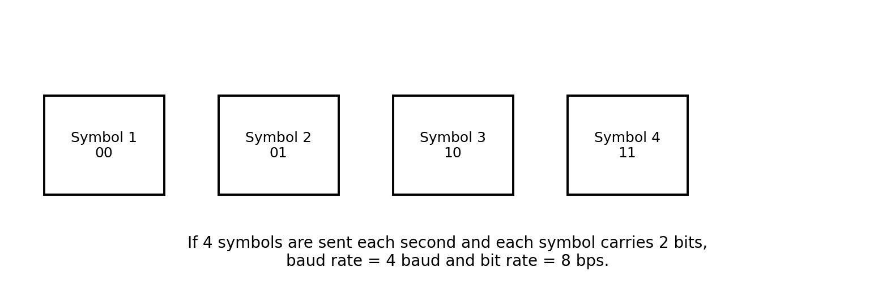
Figure 6. Example showing the difference between bit rate and baud rate
Solved example
Suppose a system sends 1000 symbols per second.
If each symbol represents 2 bits, then:
Bit rate = 1000 × 2 = 2000 bps
Baud rate = 1000 baud

Quick memory idea
Bits are the information content; baud is the signaling speed.

1.12 Numerical
This section is mainly for formula-based practice from Shannon capacity, bit rate, baud rate, and related conversion questions.
Numerical 1: Bit rate from baud rate
Given: baud rate = 2400 baud, bits per symbol = 3
Formula: bit rate = baud rate × bits per symbol
Calculation: bit rate = 2400 × 3 = 7200 bps
Answer: bit rate = 7200 bps

Numerical 2: Baud rate from bit rate
Given: bit rate = 9600 bps, bits per symbol = 4
Formula: baud rate = bit rate / bits per symbol
Calculation: baud rate = 9600 / 4 = 2400 baud
Answer: baud rate = 2400 baud

Numerical 3: Shannon capacity using SNR in dB
Given: B = 4000 Hz, SNR = 20 dB
First convert to linear ratio: S/N = 10^(20/10) = 100
Now use C = 4000 log2(1 + 100) = 4000 log2(101)
Since log2(101) ≈ 6.66, C ≈ 4000 × 6.66 = 26,640 bps
Answer: channel capacity ≈ 26.64 kbps

1.13 Line Coding (Unipolar, Polar and Bi-Polar)
Line coding is the process of representing digital data as digital signals suitable for transmission over a communication medium. The receiver observes voltage or signal levels and interprets them back into bits.
A good line coding technique should make transmission easy, reduce ambiguity, help synchronization, and avoid unnecessary DC components.
- Unipolar line coding: one polarity is used. Usually 1 = positive voltage and 0 = zero voltage.
- Polar line coding: two polarities are used. Example: 1 = +V and 0 = -V.
- Bipolar line coding: three levels are used. Usually 0 = 0 voltage and 1 alternates between +V and -V.
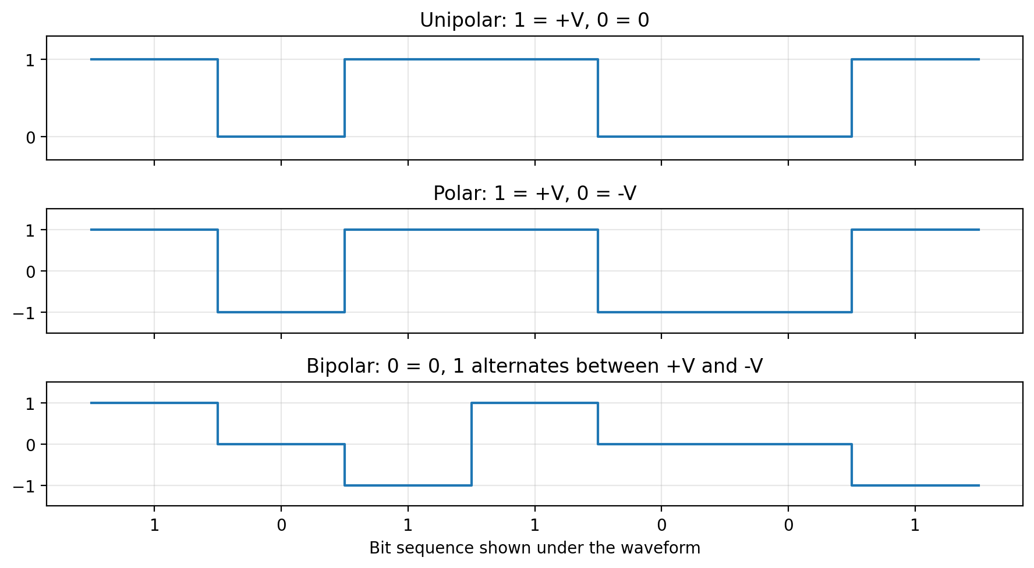
Figure 7. Typical waveforms for unipolar, polar, and bipolar line coding
Type | Features
Unipolar | Very simple, but has a strong DC component and poor synchronization for long runs.
Polar | Uses both positive and negative voltage; better than unipolar in many cases.
Bipolar | Reduces DC component and improves synchronization because 1s alternate in sign.

Simple understanding
Suppose the bit sequence is 1 0 1 1 0.
In unipolar coding, 1 is represented by +V and 0 by 0.
In polar coding, 1 may be +V and 0 may be -V.
In bipolar coding, every 1 alternates between +V and -V, while 0 stays at 0.

Mnemonic
U-P-B = One sign, Two signs, Three levels

Quick Revision Sheet
- Data communication = exchange of data between devices through a medium.
- Modes = simplex, half-duplex, full-duplex.
- Characteristics = delivery, accuracy, timeliness, jitter.
- Main components = sender, message, medium, receiver, protocol.
- ADC steps = sampling, quantization, encoding.
- Nyquist: fs ≥ 2fmax
- Shannon: C = B log2(1 + S/N)
- Bit rate = baud rate × bits per symbol
- Line coding = unipolar, polar, bipolar

Exam questions for Unit 1

A. Short-answer-type questions with model answers
Q. What is data communication? A. Data communication is the exchange of data between two or more devices through a transmission medium using agreed communication rules.
Q. Define simplex transmission. A. Simplex transmission is a one-way communication mode in which data flows only from sender to receiver.
Q. State any four characteristics of effective data communication. A. The main characteristics are delivery, accuracy, timeliness, and jitter.
Q. What is Nyquist rate? A. Nyquist rate is the minimum sampling frequency equal to twice the highest frequency present in a signal.
Q. What does Shannon theorem tell us? A. Shannon theorem tells the maximum theoretical error-free data rate of a noisy channel.
Q. Differentiate bit rate and baud rate. A. Bit rate is the number of bits per second, whereas baud rate is the number of symbols or signal changes per second.
Q. What is line coding? A. Line coding is the method of converting digital data into digital signal levels for transmission.

B. Long-answer-type questions with answer outline
Q. Explain the components of a data communication system with a neat diagram.
- Define data communication.
- List sender, message, medium, receiver, and protocol.
- Draw a neat communication diagram.
- Explain the role of each component with one example.
Q. Explain Nyquist Sampling Theorem and Shannon Channel Capacity Theorem with formula and examples.
- Write the statement and formula of the Nyquist theorem.
- Solve one simple sampling numerical.
- Write the Shannon formula and define each term.
- Solve one capacity example and conclude the importance.
Q. What is line coding? Compare unipolar, polar, and bipolar line coding schemes.
- Define line coding and its purpose.
- Describe unipolar, polar, and bipolar coding.
- Draw simple waveforms.
- Compare their voltage levels, DC component, and synchronization behavior.
Final advice for students
Learn the definitions exactly as given in the note.
Practice drawing three diagrams neatly: transmission modes, digital communication block diagram, and line coding waveforms.
Practice at least four numericals: two from Nyquist and two from Shannon/bit rate and baud rate.
In long answers, use headings, formulas, and one small example. This improves marks and presentation.

